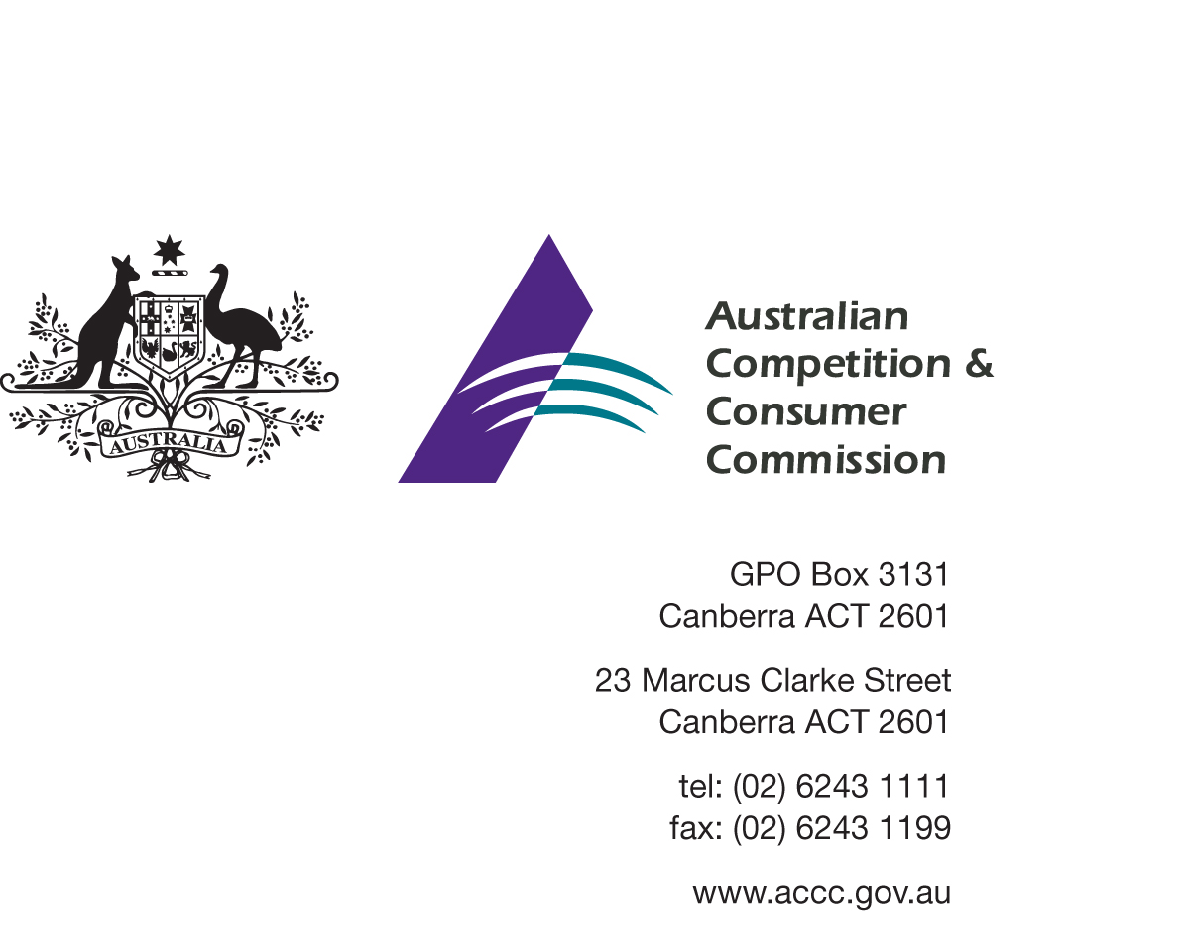

Review of the Consumer Product Safety Standard for
Child Restraints

23 June 2014

Contents
1. Introduction - 3 -
2. Purpose - 3 -
3. Background - 4 -
5. The Australian consumer product safety system - 6 -
6. Child restraint ‘supply’ and ‘use’ laws - 6 -
7. Review of the safety standard - 7 -
8. Proposed option - 10 -
9. Consultation - 10 -

Disclaimer
The Australian Competition & Consumer Commission (ACCC) has developed this consultation paper to seek the views of key Australian stakeholders about the proposed changes to the mandatory standard for child restraints for use in motor vehicles (this includes Commonwealth, State/Territory government agencies, NGOs and industry stakeholders).

No final policy decisions have been made about the proposed changes.

The ACCC will consider all feedback provided in response to this consultation in developing its recommendation to the Commonwealth Minister who administers Part XI of the Competition and Consumer Act 2010.

This material may be faithfully reproduced or forwarded to any other interested parties or referenced on public websites, provided the Australian Competition and Consumer Commission is acknowledged as the source of the material and directions to access the full document are provided. For more information, contact the Director Publishing, Australian Competition and Consumer Commission, GPO Box 3131, Canberra ACT 2601.

Introduction
Where a consumer product is potentially hazardous the Australian Government can choose whether to take action to remove or action to reduce the possibility that those goods pose a risk of injury to a person. This choice needs to be fully informed by analysis and consideration of the regulatory problem, including the development and assessment of all viable options. When market intervention is necessary, the best option available will offer an overall net benefit without undue compliance burdens.
The Commonwealth Minister who administers Part XI of the Competition and Consumer Act 2010 (the CCA) may impose requirements on the supply on consumer goods. This may include making or declaring safety standards. The Commonwealth Minister does not need to be satisfied of any particular criteria before making a safety standard. A safety standard may consist of such requirements as are reasonably necessary to prevent or reduce the risk of injury to any person. Where an Australian Standard exists that addresses potential risks of injury to a person the Commonwealth Minister may declare that Australian Standard (with or without variation) to be a safety standard for the CCA. Whether it is declared or made, the notice of a safety standard is a legislative instrument for the purposes of the Legislative Instrument Act 2003.
The ACCC conducts analysis of potential safety risks posed by some consumer products, develops management options through consultation and makes recommendations to the Commonwealth Minister. In doing so, the ACCC is cognisant of the Australian Government’s wider regulation policy. This means that:
- recommendations must balance the interests and safety of consumers against compliance costs to business and the community; and
- principles-based or outcome based regulation needs to be considered, as it is more likely to accommodate changes to manufacturing, allow for innovation and reduce compliance costs.
Where a mandatory consumer product safety standard applies to a consumer good, suppliers must not supply or offer to supply the product if it does not comply. The Australian Consumer Law (the ACL) provides for significant penalties for a breach of a safety standard or permanent ban. The maximum penalty for breach of a safety standard or permanent ban is $1.1 million for a corporation and $220,000 for an individual.

Purpose
The purpose of this paper is to consult with stakeholders on a proposal to alter the mechanism by which the Australian government ensures that child restraints supplied in Australia for use in motor vehicles do not pose a risk of injury to a child travelling in a motor vehicle as a passenger and are legally able to be used, i.e. are fit for purpose.
This paper seeks views and relevant information from interested parties that will assist in assessing the proposal to alter the way in which the provisions of the CCA are used to meet the government’s objectives relating to the safety and usefulness of child restraints. The current method is through use of a mandatory product safety standard (the safety standard) which references several versions of AS/NZS 1754 with some variations. It is proposed that in future the general provisions of the CCA be used to support AS/NZS 1754 and the existing regulations of the State and Territory road authorities.
Of particular interest in this consultation is any factual information which will assist in assessing the potential impacts and benefits of the proposal. Stakeholders should indicate their view of the change, their rationale and any evidence that supports their view.
The Office of Best Practice Regulation has advised the Australian Competition and Consumer Commission (ACCC) that a Regulation Impact Statement is not required. The consultation process outlined in this paper may be the only opportunity for stakeholders to provide their input into the review process. All interested parties are encouraged to make submissions on the options or other issues relevant to the review even if they agree with the preferred option set out below.

Background
The current safety standard
A safety standard is currently in place for child restraint systems for use in motor vehicles. It first came into effect on 7 November 1978 and was last amended 7 May 2011. The safety standard was first made under the provisions of the Trade Practices Act 1974 (the TPA). The Australian Consumer Law (ACL), which is Schedule 2 to the CCA, took effect on 1 January 2011. Safety standards made under the TPA, such as the current safety standard for child restraints, continued in force as if they had been made under the ACL.
The safety standard is a legislative instrument and is registered on the Federal Register of Legislative Instruments (FRLI) as Consumer Protection Notice No. 21 of 2011- Safety Standard: Child Restraint Systems for Use in Motor Vehicles.
The purpose of the safety standard is to support a broader road safety objective of reducing injuries to children involved in motor vehicle accidents. It ensures that child restraints supplied on the Australian market have key safety features considered reasonably necessary to reduce the risk of injury to/death of a child while travelling in a motor vehicle.
A person must not, in trade or commerce, supply consumer goods of a particular kind if a safety standard for consumer goods of that kind is in force and those goods do not comply with the standard.
The safety standard declares that the 2000, 2004 and 2010 versions of AS/NZS 1754, with some variations is a safety standard for the purpose of s105 of the ACL. The safety standard has requirements, based on the requirements described in AS/NZS 1754 which relate to:
materials;
design and construction;
performance;
testing;
instructions to be supplied for installation of the upper anchorage fittings;
an explanation of the new shoulder designation system for choosing an appropriate child restraint;
informative labelling, instructions, marking and packaging; and
clothing for test dummies, spacers for attachment to test dummies, and recommended dummy types.
The 2013 version of AS/NZS 1754
AS/NZS 1754 was revised during 2011 – 2013 and published in June 2013 as AS/NZS 1754:2013. It introduced a number of new elements including: features that an ISOFIX compatible child restraint must meet, a new Type A4 child restraint allowing children to stay rear facing for longer, changes to the inbuilt harnesses to cater for children up to about 8 years old and provision of an instruction booklet with the child restraint.
Two new testing requirements, one relating to the test sled used and another requiring regular testing of products (or batch testing) have been introduced to demonstrate on-going product compliance with the AS/NZS 1754:2013.
- The Australian Consumer Law
The ACL is a single, national law covering consumer protection and fair trading which applies in the same way nationally and in each state and territory of Australia.
Australian Government policy requires that each regulatory proposal or consideration contemplate whether the proposed regulatory intervention is necessary and test which is the best option available. It is important to note that when the safety standard was last reviewed, the full impact of the ACL had not become clear.
The ACL includes a number of provisions which are particularly relevant to consider as part of this review as they may be used by Fair Trading agencies and in the absence of a mandatory standard. This is discussed further below.
Section 18 of the ACL is one of a number of provisions which provides general protection to consumers. It states that a person must not, in trade or commerce, engage in conduct that is misleading or deceptive or is likely to mislead or deceive.
Section 29 of the ACL is a provision which provides a specific protection to consumers against false or misleading representations about goods.
Together, these two sections mean that a supplier must not engage in conduct that is false, misleading or deceptive or likely to be so. An incorrect representation by a supplier that a child restraint system for use in motor vehicles meets a particular standard may be proved to be a breach of one or both these provisions. Similarly, an incorrect representation that a child restraint system will meet a user’s obligation under road safety regulations to only use a child restraint which meets AS/NZS 1754 may also be proved to be a breach of one or both these provisions.
Section 54 of the ACL provides for consumer guarantees that goods are of acceptable quality including that they are free from defects and safe. Section 55 provides consumer guarantees that goods are reasonably fit for any disclosed purpose. These provisions are relevant in that child restraints must be free from defects, safe and reasonably fit for any purpose. A parent or carer purchasing a restraint will be doing so for a variety of reasons including, to protect a child being transported and to comply with state and territory ‘use’ laws (see discussion below).
The ACL provides for consumers to take action against suppliers and in some cases manufacturers for a breach of consumer guarantee provisions. Section 277 provides for the regulator to take action on behalf of consumers (with their written consent).
Section 122 of the ACL provides for the compulsory recall of consumer goods which will or may cause injury to any person. In the majority of cases where unsafe goods are identified, the ACCC and the supplier of the goods negotiate a voluntary recall. However, the option to use powers in the ACL to compulsorily recall unsafe goods is also available.

The Australian consumer product safety system
Section 105(1) of the ACL allows the Commonwealth Minister to declare an Australian Standard either in whole or part, with additions or variations, to be a safety standard for consumer goods. Section 104 of the ACL allows the Commonwealth Minister to make a safety standard for consumer goods which sets out requirements for those consumer goods which may be reasonably necessary to prevent or reduce the risk of injury to any person.
Section 106 of the ACL states that a person must not in trade or commerce, supply, offer for supply or manufacture for supply, consumer goods of a particular kind if those goods do not comply with a safety standard currently in force for those goods.
A safety standard for child restraints regulates the supply of restraints. The term ‘supply’ in relation to consumer goods (such as child restraints) means to supply by way of sale, exchange, lease, hire or hire-purchase.
Safety standards made under the ACL are co-operatively enforced by the ACCC and state and territory fair trading agencies.

Child restraint ‘supply’ and ‘use’ laws
While the CCA provides for the development and enforcement of safety standards which affect the supply of child restraints it does not allow for laws which govern which restraints can be legally used in each jurisdiction. That responsibility falls to state and territory road safety agencies.
State and territory road and traffic agency Ministers make legislation in relation to child restraint use. Each state and territory requires that a child carried in a motor vehicle is restrained in a way appropriate to their age and size and that the restraint used be one approved by state and territory road safety regulation. Each jurisdiction then defines an approved restraint. These use laws are enforced by Police in each state and territory.
Whilst use laws may vary slightly between states and territories, they are all based on AS/NZS 1754. At least one jurisdiction requires that child restraints be certified as meeting AS/NZS 1754 while most require that restraints comply with the standard.
There is some variation in the specifics of which versions of AS/NZS 1754 are legal to use in the various jurisdictions. The Commonwealth has no power in relation to these laws and any action flowing from the current consultation will not affect them.

Review of the safety standard
Following the public comments made in response to the November 2013 consultation, discussion with experts and interested groups and further research and review, the ACCC is now actively considering the best way to ensure that child restraints supplied to the Australian market provide protection to children in motor vehicles.
This active consideration was triggered by comments expressing concern over differences between the requirements in AS/NZS 1754 (various years) and the safety standard and, specifically, the proposal that some provisions of AS/NZS 1754:2013 not be incorporated in a new safety standard. Stakeholders, particularly road safety authorities, were concerned that any variation between the requirements in AS/NZS 1754 and in the safety standard had the potential to allow non-compliant (with AS/NZS 1754), possibly unsafe, restraints to be sold and/or the potential to contribute to confusion among suppliers and consumers over the differences.
While there is no evidence that these concerns have manifested themselves since the introduction of the safety standard in 1978, the ACCC is of the view that these are important issues which should be properly considered and that the current method of supporting the road safety objectives associated with child restraints may not be the best way forward in the current legal environment.
As noted above, the safety standard was first made under the provisions of the TPA and came into effect on 7 November 1978 and was last amended 7 May 2011. At the time this was the principle means of regulating what child restraints could be supplied (and therefore used) in Australia.
State and Territory authorities started to enact regulations in the mid-1980s stipulating which child restraints were to be used in their jurisdictions. It became illegal to use child restraints which did not comply with a version, or versions of AS/NZS 1754 and the systems of ‘supply’ regulation and ‘use’ laws has overlapped for more than 25 years.
In recent years the AS/NZS 1754 has matured considerably, grown more complex and longer, doubling in length in 2013. At the same time the national transition from the TPA to the ACL has introduced a new consumer guarantee regime relating to acceptable quality.
In reviewing the responses to the November 2013 Consultation Paper and in subsequent research and discussion the ACCC has noted a number of issues relating to the overlapping system of regulation.
- Duplication/Efficacy – the safety standard partially duplicates with fewer requirements the provisions of the road safety (or ‘use’) laws using requirements from AS/NZS 1754. Road safety ‘use’ laws and the requirements of the sole body presently registering compliance (SAI Global) ensure that all products on the market comply with all requirements of AS/NZS 1754. No child restraints are produced that only conform to the safety standard. There is no prospect this situation will change.
- Contribution to safety/efficiency – it appears that the safety standard has not had a direct effect on child restraints since road regulations required full compliance with AS/NZS 1754. For at least ten years (from 1978) the safety standard was ‘reasonably necessary to prevent injury’ as the only regulation on performance requirements for child restraints. States and Territories have had nationally consistent requirements to use AS/NZS 1754 compliant restraints for at least 20 years. All State and Territory road safety ‘use’ laws require full compliance with AS/NZS 1754 as a minimum with one State (South Australia) requiring certification to AS/NZS 1754.
- Actual/Potential mismatch in safety standard/use requirements – road authorities and safety organisations express anxiety over actual and or perceived differences between the safety standard and AS/NZS 1754 on the basis of their potential to adversely affect road safety outcomes. Specifically they are concerned that restraints which may be non-compliant with AS/NZS 1754 will be sold and that consumers are or will be confused.
- Confusion – with two different types of regulation by two safety related authorities/regimes – any differences between the safety standard and the road safety use laws are difficult for non-experts to understand both in principle and in detail. Having different requirements from the two areas of authority (those regulating supply and those regulating use) gives rise to concern of consumer confusion. It is argued that the user laws are simple: “use an Australian Standard restraint”.
- Adjustments are incremental and safety improvements hard to quantify: The AS/NZS 1754 standard doubled in length between the 2010 and 2013 versions. The 2010 standard involved a substantial change, in moving to a height based system (previously weight and age based) and the 2013 version introduced the notion that child restraints with ISOFIX features can be AS/NZS1754 compliant (and the rebound sled and batch testing). Many changes in AS/NZS 1754 are incremental and/or small – for example changes in the weight of a hyphen, in a font size or in the style of text from justified to centred format. As such ‘safety improvements’, which form the basis of power to regulate under the ACL and underpin adjustments in the safety standard, can be difficult to identify and measure.
ISOFIX (under various names) is a standard for attaching child restraints to vehicles without using seat belts. ISOFIX anchorage points are now regularly supplied in Australian vehicles, e.g. GM Holden advise these are now standard fittings, and in imported vehicles. The system has been in development since 1997. The 2013 revision is the first time ISOFIX features have appeared in AS/NZS 1754.
- Specific regulatory difficulty mandating some provisions of voluntary standard – the 2013 version of AS/NZS 1754 includes two provisions that are considered by stakeholders to be of great significance but which are considered difficult to incorporate into a safety standard. These are the specification of a test mechanism (rebound sled) and a regime for regular product testing (batch testing). The proposal in the November 2013 Consultation Paper to exclude these from a remade safety standard elicited significant concern and adverse comment.
- Mandatory standard process brings delays, duplicate processes, uncertainty in timing: once a revised version of AS/NZS 1754 is published the ACCC practice has been to review the changes and then conduct a public consultation on possible changes to the safety standard. As most stakeholders contribute to the development of AS/NZS 1754 or comment on the draft standard the process for the safety standard partly duplicates the comment process for AS/NZS 1754. With best endeavours, there is usually about a year between the publication of the latest version of AS/NZS 1754 and registration of the revised safety standard. Industry indicates that in the absence of the safety standard process they would immediately start manufacturing to the revised AS/NZS 1754 upon publication. The current revision of the safety standard is causing uncertainty for industry because of consumer demand for restraints with ISOFIX features which the new version of AS/NZS 1754 includes for the first time. This issue is made even more complex because previous versions of AS/NZS 1754 were silent on child restraints with ISOFIX features and there was an assumption, perhaps misplaced, that child restraints with ISOFIX features could not meet the requirements of earlier versions of AS/NZS 1754 or the safety standard.
- The safety standard has never been used to prosecute suppliers and there is minimal concern over ‘unsafe’ products. There is little or no safety concern with child restraints (the 2013 review identifies few safety concerns with child restraints). In the Australian market there have been markedly fewer product recalls than in the US. There have been safety warning notices issued about online purchase and media alerts issued warning against importing restraints built to overseas standards. Key stakeholders note that most discussion is about correct fitting and the only product issues are about quality assurance errors that have been identified by suppliers.
- Other tools are available to support safety. The ACCC believes the recall and general consumer guarantee provisions of the ACL are sufficient to maintain the safety of child restraints (without the need for a safety standard). On the basis that any child restraint that does not comply with AS/NZS 1754 cannot legally be used, it is most unlikely to be of acceptable quality, ‘fit for purpose’, ‘of merchantable quality’ and probably be ‘unsafe’ (elements of the Consumer Guarantees regime under the ACL).
The capacity of the ACCC to stop the sale of unsafe child restraint products and to have the product recalled removed from the market will remain. The penalties associated with non-compliance with a safety standard will no longer be available. Relevant general powers within the ACL include:
- Section 18 of the ACL states that a person must not, in trade or commerce, engage in conduct that is misleading or deceptive or is likely to mislead or deceive.
- Section 29 of the ACL protects consumers against false or misleading representations being made about goods.
- Claims of compliance with the Australian Standard must be truthful or suppliers risk breaching section 18 and/or section 29 of the ACL.
- Section 54 of the ACL provides consumer guarantees that goods are of acceptable quality including that they are free from defects, safe and fit for all the purposes for which goods of that kind are commonly supplied.
- Section 122 and 128 of the ACL provides for recall of goods which “will or may” cause injury.

Proposed option
The ACCC is proposing to move to use of the general powers of the ACL to support the existing State and Territory road user regulations relating to child restraints and to support AS/NZS 1754.
The advantages of the change include: the end of any conflict or perceived conflict between the mandatory safety standard and road regulation user laws; a clearer message to suppliers to comply with, and consumers to use child restraints that meet, AS/NZS 1754; a reduction in delays in implementing revisions to AS/NZS 1754; removal of an unnecessary layer of regulation and consultation process; and, of primary importance, no change in the performance and safety of child restraints.
Such a change would neither exacerbate nor resolve some issues in relation to child restraints including existing minor inconsistencies in use laws across the jurisdictions; individuals importing and using restraints that are non-compliant with AS/NZS 1754; children being placed in inappropriate restraints; or children being carried unrestrained.
Submissions in this public consultation and additional information provided by stakeholders will inform advice prepared for the Commonwealth Minister on how best to support the safety of child restraints.
If the proposal to rely on the general powers of the ACL is to be implemented the existing safety standard would be revoked and all publicity material and information on the Product Safety Australia website would be revised to refer to AS/NZS 1754 and to the state and territory road use regulations.
If further investigation indicates that the proposed use of the general powers would not be effective or efficient in maintaining the safety of child restraints the ACCC would prepare advice to the Minister on revision of the existing safety standard.

Consultation
Stakeholders are invited to make submissions or comment on the proposal outlined in the paper. Stakeholders are requested to explain the thoughts behind their position and, where relevant, provide supporting evidence or documentation.
Stakeholders that support the preferred option should still make a submission and provide reasons for supporting that option.
It would be of assistance if submissions address three areas:
- The principle of using the general provisions of the ACL to support the Australian Standard and the existing road authority use laws.
- Issues or arguments on the detail of use of the general powers of the ACL and the revocation of the existing safety standard.
- Information or research relating to the issues or arguments, particularly those relating to costs and to differences in cost under the existing and proposed mechanism of support.

Submissions should be sent to the ACCC by close of business, Friday 18 July 2014, via:
- Internet via the ACCC Consultation hub (https://consultation.accc.gov.au/).
- Email: productsafety.regulation@accc.gov.au
- Post:
Director
Recreation and Automotive Products
Product Safety Branch
Australian Competition and Consumer Commission
GPO Box 3131
CANBERRA ACT 2601
If the information provided is of a confidential nature the details provided by you will be treated confidentially. That is, the ACCC will not disclose the confidential information to third parties, other than advisors or consultants engaged directly by the ACCC, without first providing you with notice of its intention to do so, such as where it is compelled to do so by law. Please note that any information which you believe to be of a confidential nature should be clearly marked or identified as confidential.
The ACCC may be compelled by law to disclose submissions (for example under subpoena or following a request under the Freedom of Information Act 1982). For more information see the ACCC-AER Information Policy available via www.accc.gov.au.

Word and PDF copies of this Consultation Paper can be found on the Product Safety Australia website at: http://www.productsafety.gov.au/content/index.phtml/itemId/1007885.

The Commonwealth Minister who administers Part XI of the Competition and Consumer Act 2010 is referred to as the Commonwealth Minister throughout this paper.
For more detailed explanation see Section 5
In the case of child restraints this Australian Standard is AS/NZS 1754 Child restraint systems for use in motor vehicles. It is referred to as AS/NZS 1754 throughout this paper.
In line with usual practice the ACCC released a Consultation Paper to facilitate the review of the safety standard for child restraint systems for use in a motor vehicle in November 2013 to seek public comment on proposed changes to the mandatory product safety standard. The paper can be viewed at http://www.productsafety.gov.au/content/index.phtml/itemId/1004111/fromItemId/973889
Available: http://www.comlaw.gov.au/Details/F2011L00721.
ISOFIX is the method of attachment which allows a child seat to clip into two rigid or flexible lower anchorage points in a motor vehicle. International Organisation for Standardisation standard ISO 13216 - attachment points for child safety seats in passenger cars specifies the anchoring system for child safety seats in the EU and is known as “ISOFIX”. This ISOFIX mechanism for attaching the seat to the lower anchors is quite different from that used in the United States and very different from the top tether and motor vehicle seat belt system used in Australia.
At the moment this service is conducted by SAI Global and incorporates third party assurance that a particular product meets the specified requirements of AS/NZS 1754. SAI Global Standards Mark™, or the 5 Tick Mark, on the product represents reliability, quality assurance and safety and is a visible, recognisable method of consumers identifying compliant child restraints. See http://www.saiglobal.com

